Name Date

Air Traffic Controller
Directions

Materials:
- “Air Traffic Controller” recording sheet
- Floor grid (could be created with tiles on the floor) or shower curtain grid
- One Person to be the air traffic controller
- Two or Three people to be airplanes
- Colored pencils/markers

Objective: To create flight plans to safely direct all planes from point A (0,0) to point B (10,10).
Directions: Getting Started:
- The Air Traffic Controller tells the planes where they need to go using coordinates on the grid.
- Each plane enters the grid at the origin-point A (0,0). This is where the Air Traffic Controller’s radar first picks up each plane’s signal. Once the Air Traffic Controller “sees” a plane, he or she must tell them where to go using coordinates.
- The Air Traffic Controller is responsible for keeping the planes, pilots, and their passengers safe from collisions with other aircrafts.
- The more planes there are in the sky, the more difficult it is to keep planes safe.
- Each Air Traffic Controller has to keep track of each plane by doing the following:
  - Each plane’s name must be written on the recording sheet.
  - The coordinates for the path that each plane takes must be written down.
  - The Air Traffic Controller must draw a flight plan on the recording sheet for each plane. Each plane must go from point A (0,0) to the final destination or landing strip, point B (10,10).
  - Submit both the coordinates and the flight plan to the FAA President (Your Teacher) at the end of this exercise.
- The job of Air Traffic Controller passes from one person to the next until all students have had the job. Once students have constructed their flight plan,

the group may move to the floor grid or shower curtain grid to make sure all planes will land safely.

Finishing Up:
Air Traffic Controllers:
Before you turn in your flight paths and coordinates, please be sure to complete the following:
- Highlight or shade each plane’s flight path a different color with a key at the bottom that shows which color represents each plane.
- Put your name on your papers.
- Turn them in to the FAA President.

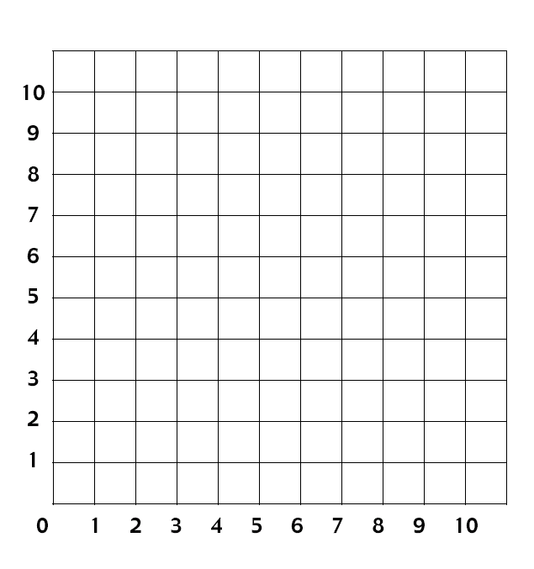
Name Date _
Air Traffic Controller

Flight Plan
 | Name & Color | Coordinates
Plane #1
Plane #2
Plane #3

