Name Date

Atlanta Landmarks
Directions: Use the coordinate grid to plot some famous landmarks of Atlanta, Georgia. Label each point.
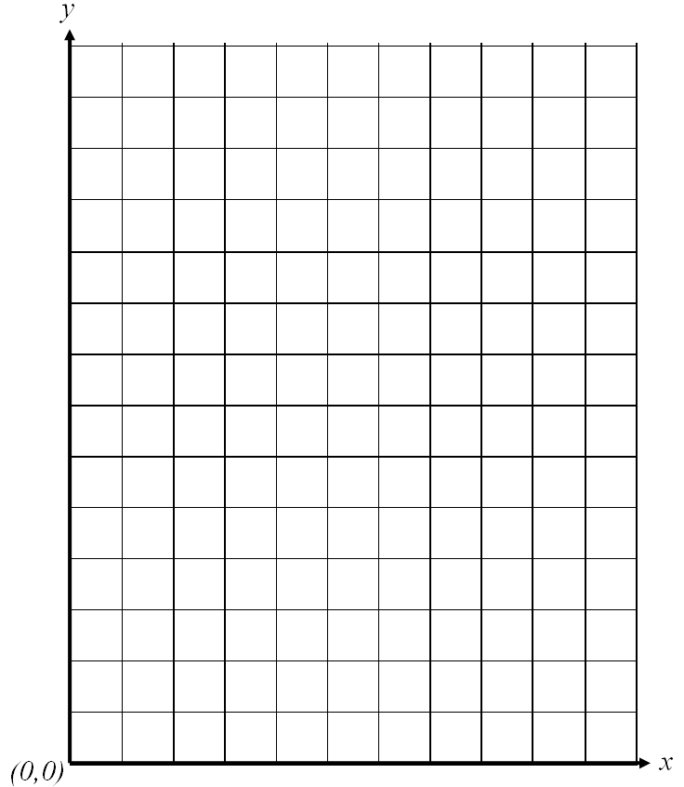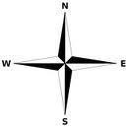
World of Coca Cola at
origin (0, 3)
Turner Field at (0, 5)
Georgia Aquarium
at (8, 6)
Fernbank Natural History
Museum at (5, 3)
Stone Mountain
at (4, 14)

Name a landmark located south of the Georgia Aquarium? Explain how you can tell that this landmark is south of the Aquarium just by looking at its coordinate points.

