Name______________________ Date___________________

Base Ten Activity
Your task is to use the base-ten blocks to represent multiplication and division with decimals. Use the decimal block values below to help you find the product or quotient of each decimal problem.

Decimal Block Values
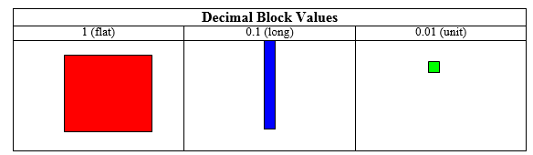

1. 4.8 times 3 2. 2.1 x 5.4
3. 0.6 x 1.9
4. 12 ÷ 0.3
5. 3.6 divided by 1.2

