Name Date

Coordinate Grid Geoboards
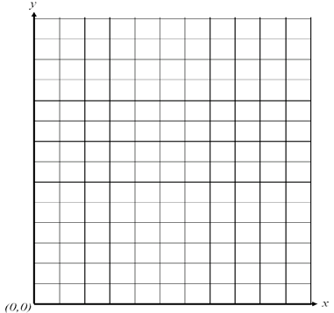
Directions: Use the coordinate grid to record polygons from the geoboard.

Compare the picture of the polygon and the actual polygon on the geoboard. Record the similarities/differences below.

