

Write 4.56 in word

form.

1



In the number 12.897

was is the value of the number in the tenths place?

2



Put the following

decimals in order from least to greatest: 3.89, 3.75, 3.823, 3.85, 3.7

3



Put the following

decimals in order from greatest to least : 0.123, 0.05, 0.075, 0.2,

0.3

4

Decimal

Task

Cards

Decimal

Task

Cards

Decimal

Task

Cards

Decimal

Task

Cards



Write five and forty-

two hundredths in standard form.

5



Use the <, > or =

56.2

56.23

6



Put the following

decimals in order from least to greatest: 45.7, 45.07, 45.89, 45.002,

45.1

7



Put the following

decimals in order from greatest to least : 6.8, 6.825, 6.75, 6.85, 6.7

8

Decimal

Task

Cards

Decimal

Task

Cards

Decimal

Task

Cards

Decimal

Task

Cards



Write the following

decimals as a fractions:

.34

.125

.24

.5

9



Use the <, > or =

4.3

4.30

10



Write the value of the

underlined digit 3.456.

11



Put the following

decimals in order from greatest to least : 2.97, 3.1, 2.945, 3.074, 2.9

12

Decimal

Task

Cards

Decimal

Task

Cards

Decimal

Task

Cards

Decimal

Task

Cards



Write 34.78 in word

form.

13



In the number 4.675

what is the digit in the tenths place?

14



Write the value of the

underlined digit 5.671

16



Put the following

decimals in order from greatest to least : 1.3, 1.35, 1.07, 1.29, 1.234

15

Decimal

Task

Cards

Decimal

Task

Cards

Decimal

Task

Cards

Decimal

Task

Cards



Write five thousandths

in standard form.

17



In the number 23.004

what is the digit in the thousandths place?

18



Put the following

decimals in order from least to greatest: 5.23, 5.02, 5.003, 5.2, 5.3

19



Which decimal is

between 3.451 and 3.9?

3.32 3.5

3.05

3.45

20

Decimal

Task

Cards

Decimal

Task

Cards

Decimal

Task

Cards

Decimal

Task

Cards



Use the <, >, or =

5.122

5.2

21



In the number 2.567

what is the digit in the hundredths place?

22



Put the following

decimals in order from least to greatest: 1.23, 1.205, 1.2, 1.25, 1.236

23



Which decimal is

between 5.23 and 5.5?

5.32 5.2

5.6

5.51

24

Decimal

Task

Cards

Decimal

Task

Cards

Decimal

Task

Cards

Decimal

Task

Cards



Use the <, >, or =

6.502

6.5

25

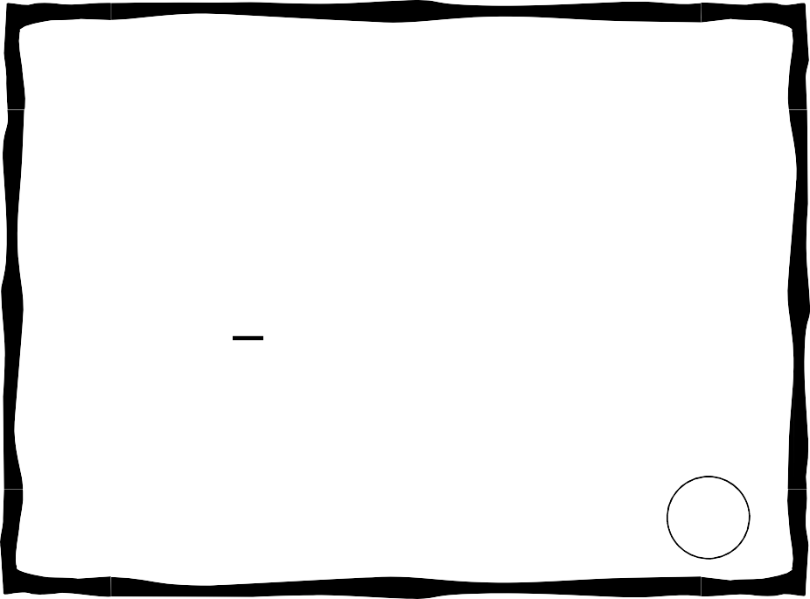

What is the value of

the underlined digit 3.458.

26



Put the following

decimals in order from least to greatest: 98.2, 98.02, 98.234, 98.22,

98.276

27



Which decimal is

between 7.4 and 7.55?

7.3 7.56

7.05

7.405

28

Decimal

Task

Cards

Decimal

Task

Cards

Decimal

Task

Cards

Decimal

Task

Cards