menu math student directions

Activity Objective(s):
- Practice adding and multiplying decimals in the “real-life” situation of dining-out at a local restaurant.
- Practice subtracting decimals to make change.
- Follow step-by-step directions to complete an activity independently.

Materials:
- 1 partner (you will each take turns being a guest AND a waiter)
- Restaurant Menu
- Copy of Menu Math Dining Receipt (1 per person)
- $20.00 in “play” money
- Copy of the Show your Work worksheet (1 per person)

Directions:
- One partner will act as a “waiter” and the other partner will act as a “guest diner”. The diner will order their meal first from the waiter. The diner only has a total of $20.00 to spend on their meal.

- The diner will use their menu to order a meal from the restaurant menu they are given.

Requ ired costs:
    - 1 entrée: this is the mai n dish, such as a hamburger, sandwich, chicken, pasta, etc.
    - 1 side dish: chips, French fries, vegetables, fruit, salad, etc.
    - 1 beverage: lemonade, soda, tea, coffee, etc.
    - Tip!! Your waiter will earn a 10% tip. (Hint: to calculate tip, multiply the cost of your Total Ch eck by 0.10 and add this to your ticket total!)

Op ti onal costs: ( Th e di ner may order any/ all of th e fol l ow ing so l ong as th eir bi l l does not exceed $ 20 . 00 ! )
    - Extra side item
    - Dessert

- The “waiter” will complete the Menu Math Dining Receipt by following these steps:
  - Write each item the diner orders under the “Item Description” column and record the cost of each item (according to the menu) next to each item description under the “Item Total” column.
  - Show your work for all of the following steps on the Show your Work worksheet and transfer your solutions to the Menu Math Dining Receipt.
    - After the diner has finished ordering, add the total cost of the food items together (don’t forget to line up decimals!!)
    - To find the total of the tax, multiply the Food Total by 0.05.
    - Add the Food Total and the Tax to find the S ub total .
    - Calculate a set Tip Amount of 10% for your excellent service. To do this, multiply the Sub total by 0.10. Add this amount to the Subtotal for the Total Ch eck .
    - Calculate change, by subtracting the Total Check from $20.00. Give the diner the correct change.

- Switch roles! The “diner” should follow the steps above to act as a “waiter” and the “waiter” will take on the role of the “diner”.

- Once both partners have completed both roles, each should turn in their “Show your Work” form and corresponding guest receipt to the teacher!

Waiter’s Name:

Date:

Show your work!

Use this sheet to complete “the work” needed to calculate the Food Total, Tax, Total Check, and Change of your diner’s meal ticket.

Food Total:  (Add the total cost of the items ordered by the diner.) | Tax:  (Multiply the Food Total by 0.05.) | Subtotal:  (Add the Food Total to the cost of Tax.)
Tip Total:  (Multiply the Subtotal Check by 0.10) | Total Check:  ( Add the Subtotal and the Ti p Total.) | Change  (Subtract the Guest Total from  $20.00.)

Menu MathDining Receipts

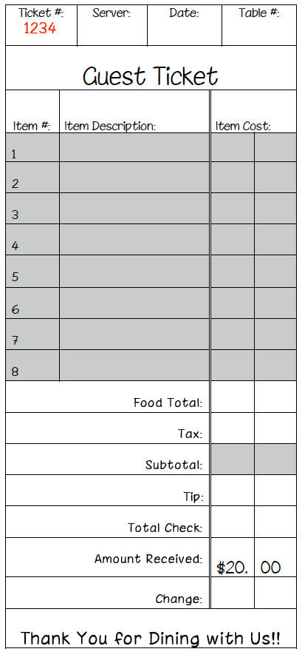

Student Name:

Date:

Menu Math Assessment rubric

CATEGORY | 5-Star Manager  4 | Waiter of the Month  3 | Waiter in Training  2 | Find a New “Day Job”  1
Accuracy | 1 or no computation mistakes were made. | 2-3 computation mistakes were made. | 4 computation mistakes were made. | More than 4 computation mistakes were made.
Neatness and Organization | The work is presented in a neat, clear, organized fashion that is easy to read. | The work is presented in a neat and organized fashion that is usually easy to read. | The work is presented in an organized fashion but may be hard to read at times. | The work appears sloppy and unorganized. It is hard to know what information goes together.
Working with Others | Student was an engaging partner, listening to suggestions of others and working cooperatively throughout lesson. | Student was an engaging partner but had trouble listening to others and/or working cooperatively. | Student cooperated with partner, but needed prompting to stay on-task. | Student did not work effectively with others.
Completion | All steps were completed. | All but 1 of the steps were completed. | All but 2 of the steps were completed. | Several of the steps were not completed.

Total Points Earned: Letter Grade:

Teacher Comments:

