Name Date

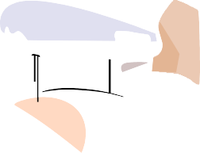
First to Arrive

Two vehicles are traveling along the same path for 5 hours. Vehicle A is traveling at a rate of 30 miles per hour. Vehicle B is traveling at a
rate of 60 miles per hour. At the completion of the trip, which vehicle will
have traveled the farthest? How much farther? Complete the tables, graph the data by creating a coordinate grid, and include a justification for your reasoning.

Car A: 30 MPH |  |  | Car B: 60 MPH
Number of Hours | Total Miles |  | Number of Hours | Total Miles
0 |  |  | 0
1 |  |  | 1
2 |  |  | 2
3 |  |  | 3
4 |  |  | 4
5 |  |  | 5

Justification:

