36 TASK CARDS
Prepositions, Interjections, and Conjunctions

ANSWER KEY INCLUDED
Just print what each student needs!

10 Interjection Cards
INTERJECTION 1
Yuck! You sneezed all over me!
- Coordinating Conjunction Cards
COORDINATING CONJUNCTION 1
You and Molly have a special friendship.

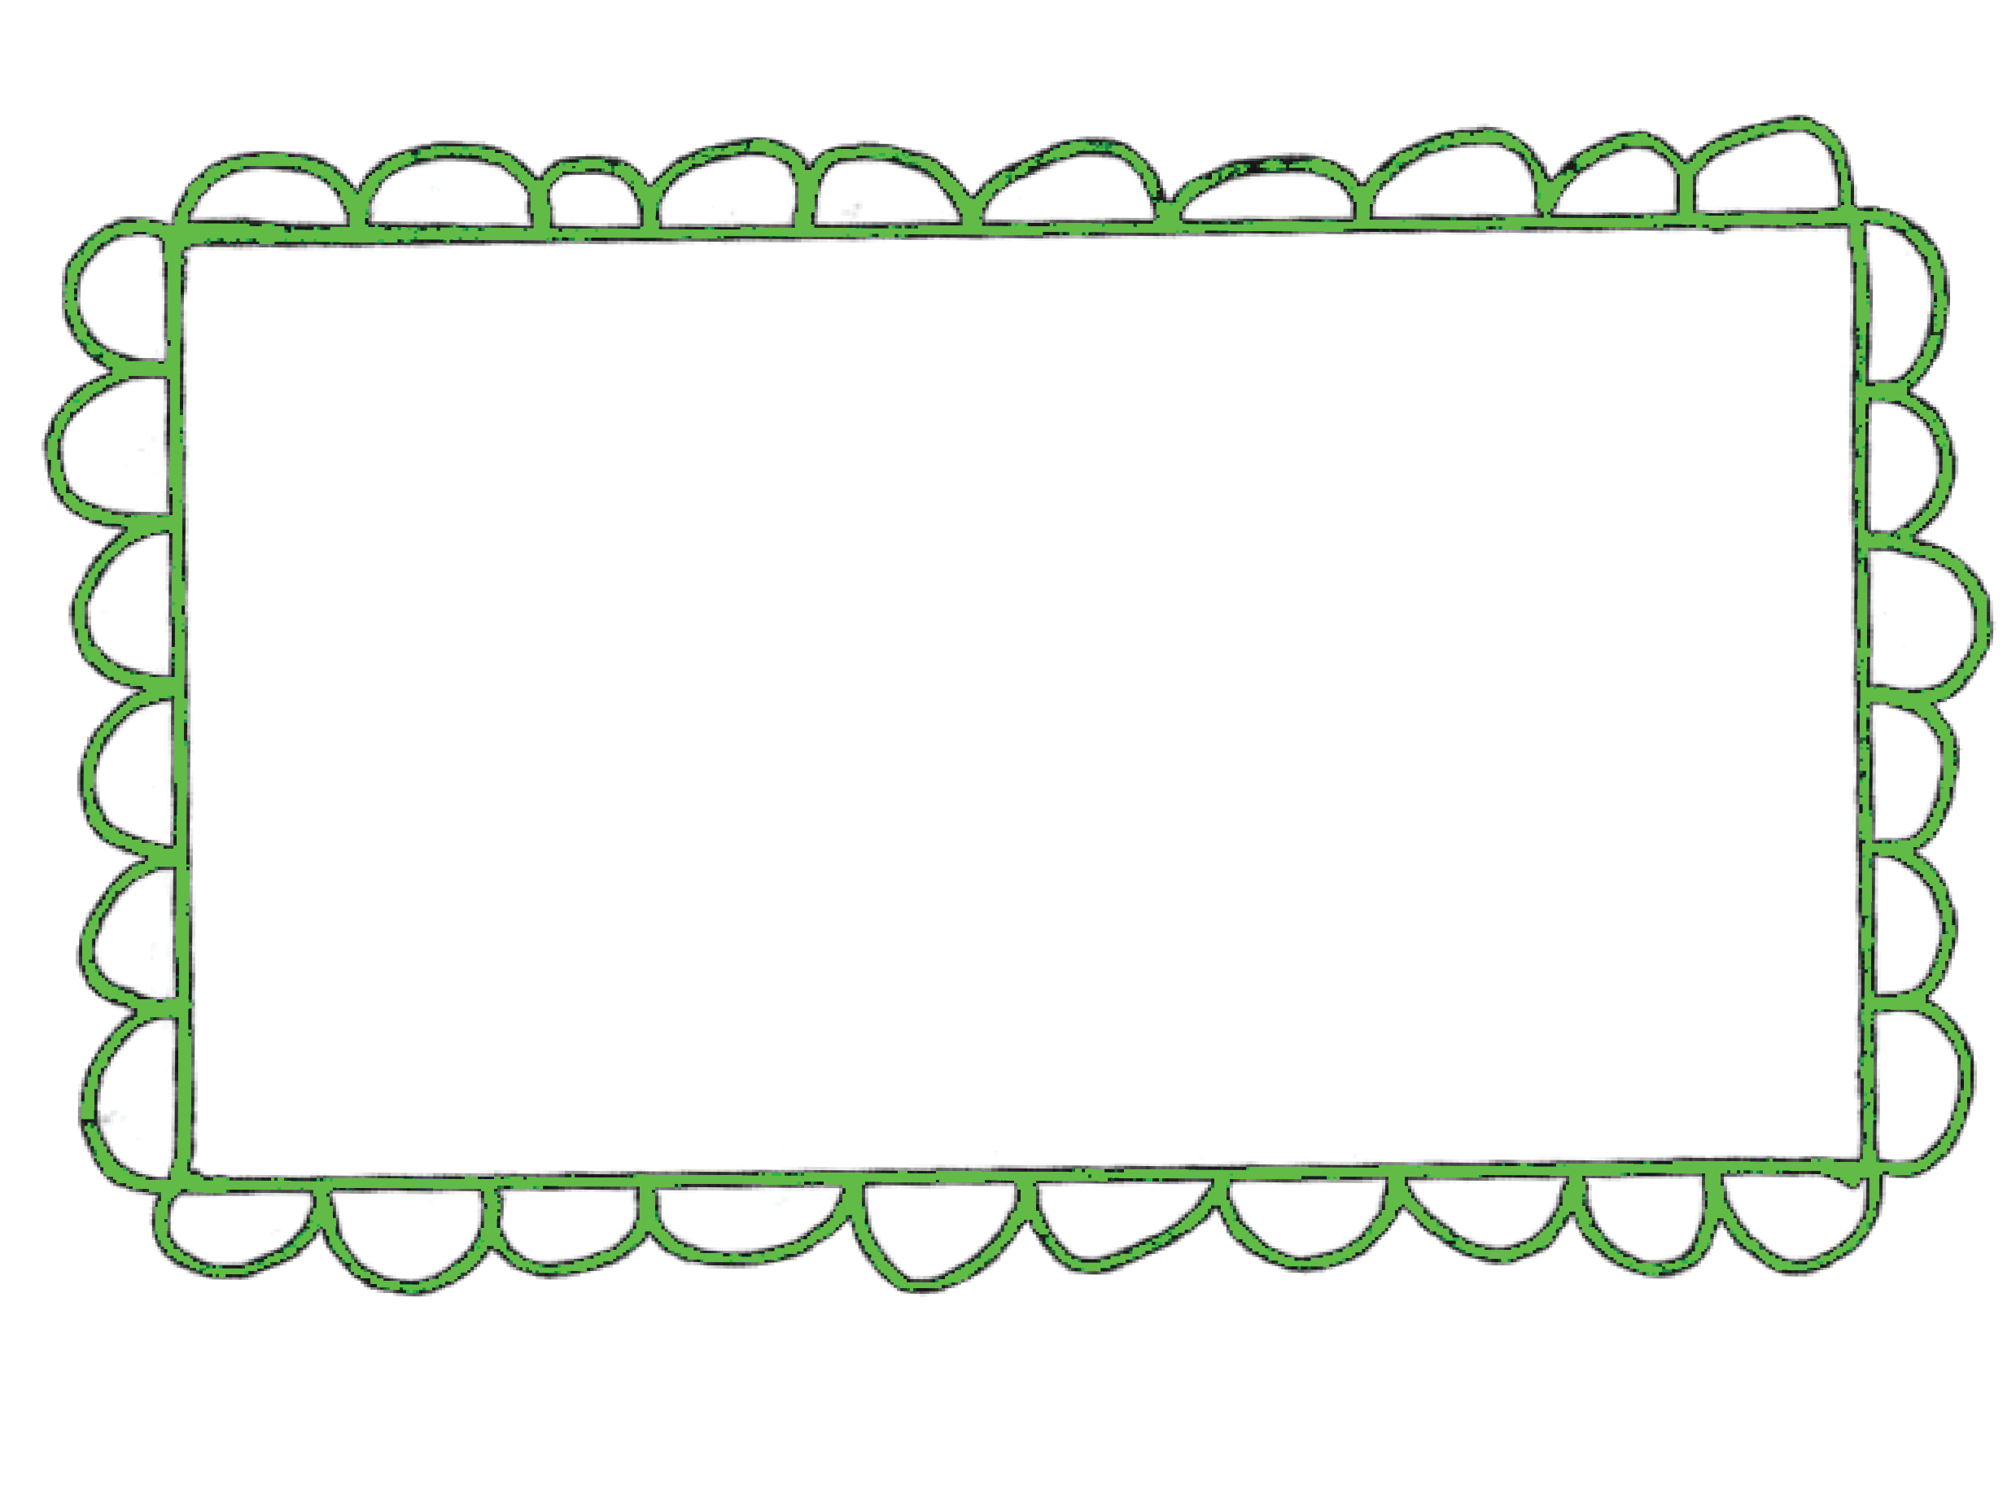Preposition Cards
PREPOSITION 1
Under the table, I saw a mouse.

5 Subordinating Conjunction Cards
SUBORDINATING CONJUNCTION 11
Because she is nice, I really want to be her friend.

Preposition, Interjection & Conjunction Reference Sheet

PREPOSITIONS- The function of a preposition is to SHOW POSITION.

ABOUT | AROUND | BETWEEN | INSIDE | OUTSIDE | UNDER-NEATH
ABOVE | AT | BEYOND | INTO | OVER | UNTIL
ACROSS | ATOP | BY | NEAR | PAST | UP
AFTER | BEFORE | DOWN | OF | SINCE | UPON
AGAINST | BEHIND | DURING | OFF | THROUGH | WITH
ALONG | BELOW | EXCEPT | ON | TO | WITHIN
AMID | BENEATH | FROM | ONTO | TOWARD | WITHOUT
AMONG | BESIDE | IN | OUT | UNDER | AMONG

INTERJECTION- The function of an interjection is to SHOW EMOTION.

*The difference between an interjection and an onomatopoeia is that an interjection does not make the sound it is describing.

Yum | Hey | Oh | Geez | Wow
Yuck | Bye | Hum | Yo | Yahoo
Ouch | Oh | Huh | Whew | Oops
Yes | Stop | Yeah | Duh | Hooray

CONJUNCTIONS- Coordinating For
The function of a conjunction
CONJUNCTIONS- Subordinating
The function of a subordinating conjunction is to connect two ideas in a sentence.

And
ALTHOUGH | AFTER | UNTIL
BECAUSE | EVEN THOUGH | UNLESS
AS | BEFORE | WHICH
THOUGH | HOW | WHILE
SINCE | THAN | WHETHER

Nor But Or Yet So
is to connect.

*When combining two sentences,
you must use a comma then the conjunction

Example: I like yellow.
You like blue.

I like yellow, and you like blue.
*In a sentence, if you have two ideas that are connected and it is NOT a coordinating conjunction- it is a subordinating conjunction.

PREPOSITION
Direction Card
- Write the prepositional phrase on your recording sheet
- Circle the preposition
- Underline the prepositional phrase
PREPOSITION 1
Under the table, I saw a mouse.

PREPOSITION 2

I saw your pencil near the book shelf.

PREPOSITION 3
Please send the note to me.

PREPOSITION
4
PREPOSITION
5
She clipped
the
the
Atop the house,
pretest
with
a
beautiful
red
bird
post-test. perched itself.

PREPOSITION
6
PREPOSITION
7
You were sweating
Beside the couch
bullets during the is the remote.
test.
PREPOSITION
8
PREPOSITION
9
A dog ran between
The
the cars,
but
hurt.
he
plane flew about
the sky.
wasn’t
PREPOSITION
10
PREPOSITION
11
From her report,
The ball went
I learned so much towards the fence.
about inherited traits.

INTERJECTION
Direction Card
- Find the interjection in each sentence.
- Write the interjection on your recording sheet.
INTERJECTION
1
Yuck! You
all
over
sneezed
me!

INTERJECTION
2
INTERJECTION
3
Yikes, I
see
did
you
not
even
Stop! Please
there.
run
don’t
the stop sign.
INTERJECTION
4
INTERJECTION
5
The
paper
hurt,
cut really
Hey, I was already
ouch!
in
line.

INTERJECTION
Direction Card
- Add an interjection into each sentence on your recording sheet.
- Write the complete sentence, including your interjection.
INTERJECTION
6
I
saw a
gigantic
spider
beside the
window.

INTERJECTION
7
INTERJECTION
8
It really stinks
in
No one seems to
here.
understand
me.
INTERJECTION
9
INTERJECTION
10
I have got to get
It has been so long
going.
since
I’ve seen you!

CONJUNCTION-
Coordinating
Direction Card
- Identify the coordinating conjunction in each sentence
- Write the conjunction on your recording sheet
COORDINATING CONJUNCTION
1
You
and
Molly
have
a
special
friendship.

COORDINATING CONJUNCTION
2
COORDINATING CONJUNCTION
3
We could take my
I have grown three
car, or we could ride
inches,
yet I still can’t
with my mom.
reach
the goal.
COORDINATING CONJUNCTION
4
COORDINATING CONJUNCTION
5
Pete will come over
I want a piano
so we can play.
for
Christmas.

CONJUNCTION-
Coordinating
Direction Card
1. Combine the two short
COORDINATING CONJUNCTION
6
I like
sentences using a comma and
a
ham.
Ham is delicious.
coordinating conjunction on your
recording sheet.

COORDINATING CONJUNCTION
7
COORDINATING CONJUNCTION
8
The photo is breath-
My bike is
taking.
Your
red.
bike is blue.
I want it!
COORDINATING CONJUNCTION
9
COORDINATING CONJUNCTION
10
Halloween is here.
Molly is not funny.
Christmas is on the
Molly
is polite.
way.

CONJUNCTION-
Subordinating
Direction Card
- Identify the coordinating conjunction in each sentence
- Write the conjunction on your recording sheet
SUBORDINATING CONJUNCTION
11
Because
she is
I
really
her
want
to
nice,
be
friend.

SUBORDINATING CONJUNCTION
12
COORDINATING CONJUNCTION
13
The game did
not
the
Even though the climb
start
until
all
was
to
scary,
I
wanted
players
showed
up.
go
anyway.
COORDINATING CONJUNCTION
14
COORDINATING CONJUNCTION
15
The lights were flashing
Since our
card, my
last
report
as the fog machine
grades
have
started.
improved.

Preposition, Interjection & Conjunction Reocrding Sheet

Interjection

Preposition

1.

2. 3.

4. 5.

6. 7.

8. 9.

10. 11.
1.
2.
3.
4.
5.
Interjection

1.

2.

3.

4.

5.
Mrs. Patrick’s Open Door

Preposition, Interjection & Conjunction Reocrding Sheet

Coordinating Conjunction

6.

7.
Coordinating Conjunction
1.
2.
3.
4.
5.

8.

9.

10.
Subordinating Conjunction
11.
12.
13.
14.
15.

Mrs. Patrick’s Open Door

