Which one is an inherited trait?
    - eye color
    - speaking Spanish
    - a raccoon that digs for food in a trash can
Which one is a learned behavior?
- scales on an alligator
- spines on a cactus
- teaching a dog tricks

Inherited traits & learned behaviors
Inherited traits & learned behaviors

Which one is an inherited trait?
- reading a book
- brightly colored feathers on a parrot
- a tree trunk scarred by lightening
Which one is a learned behavior?
- black tongue on a Chow dog
- snow boarding
- straight hair

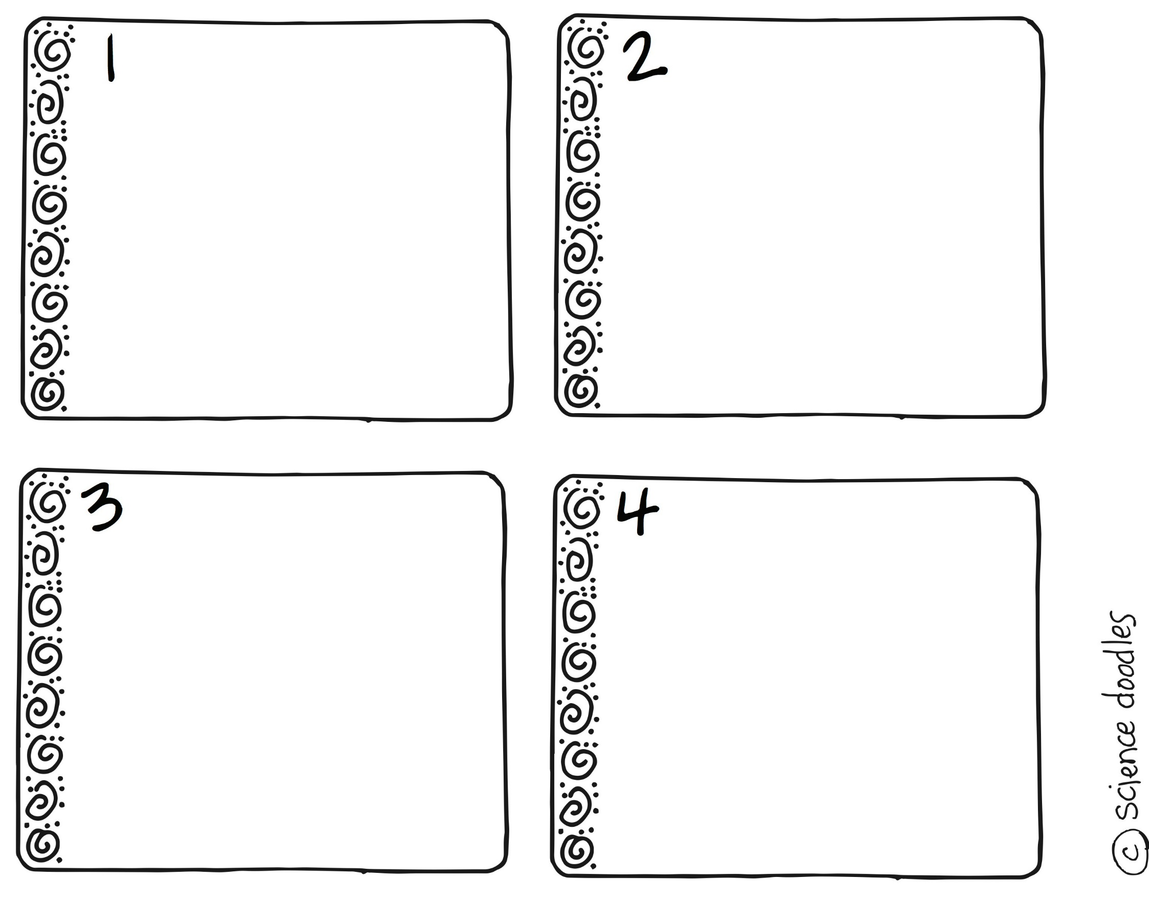
Inherited traits & learned behaviors Inherited traits & learned behaviors

Which one is an inherited trait?
- a dog begging for food
- cooking a meal
- Breathing when a baby is born
Which one is a learned behavior?
- a dog rolling over
- curly hair
- skunk spray

Inherited traits & learned behaviors

Inherited traits & learned behaviors

Which one is an inherited trait?
- roller skating
- riding a bike
- the taste of an apple
Which one is a learned behavior?
- reading a book
- beak shape
- rolling your tongue

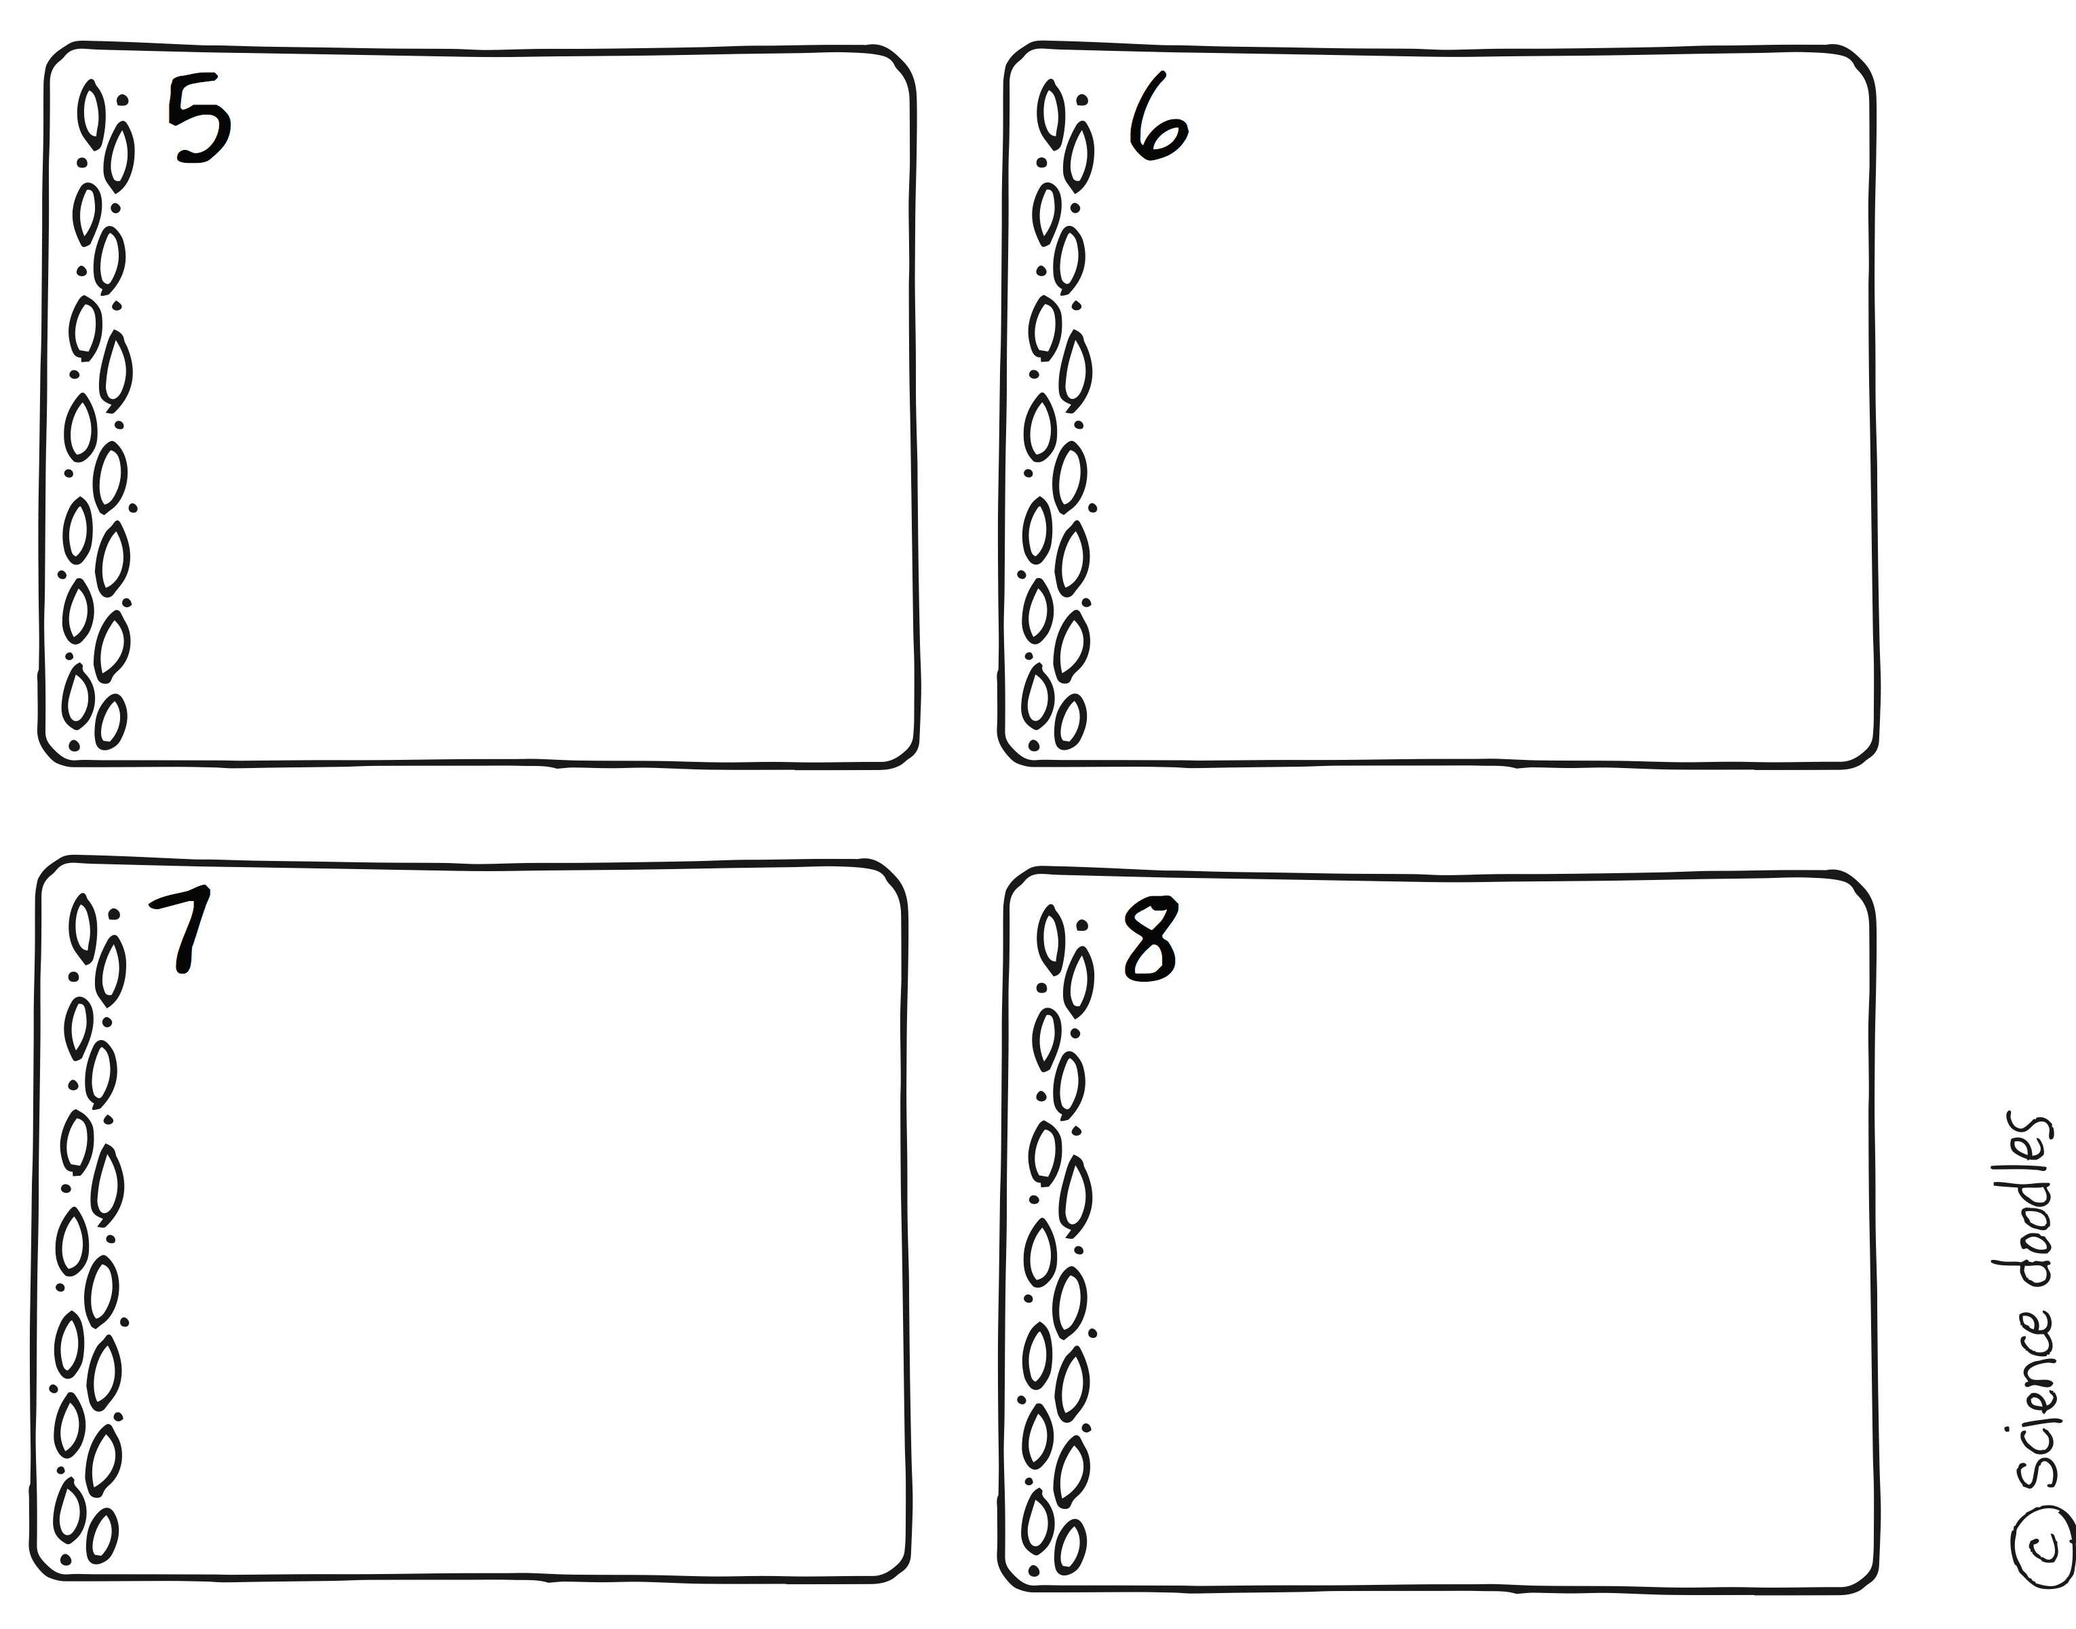

Inherited traits & learned behaviors Inherited traits & learned behaviors

Which one is an inherited trait?
- reading a book
- a chick pecking out of its shell
- a dog rolling over
Which one is a learned behavior?
- migrating south for the winter
- playing football
- shape of nose

Inherited traits & learned behaviors
Inherited traits & learned behaviors

Which one is an inherited trait?
- a bee flying from flower to flower to find pollen
- a seal balancing a ball
- tying your shoe
Which one is a learned behavior?
- stripes on a tiger
- skunk spray
- manners

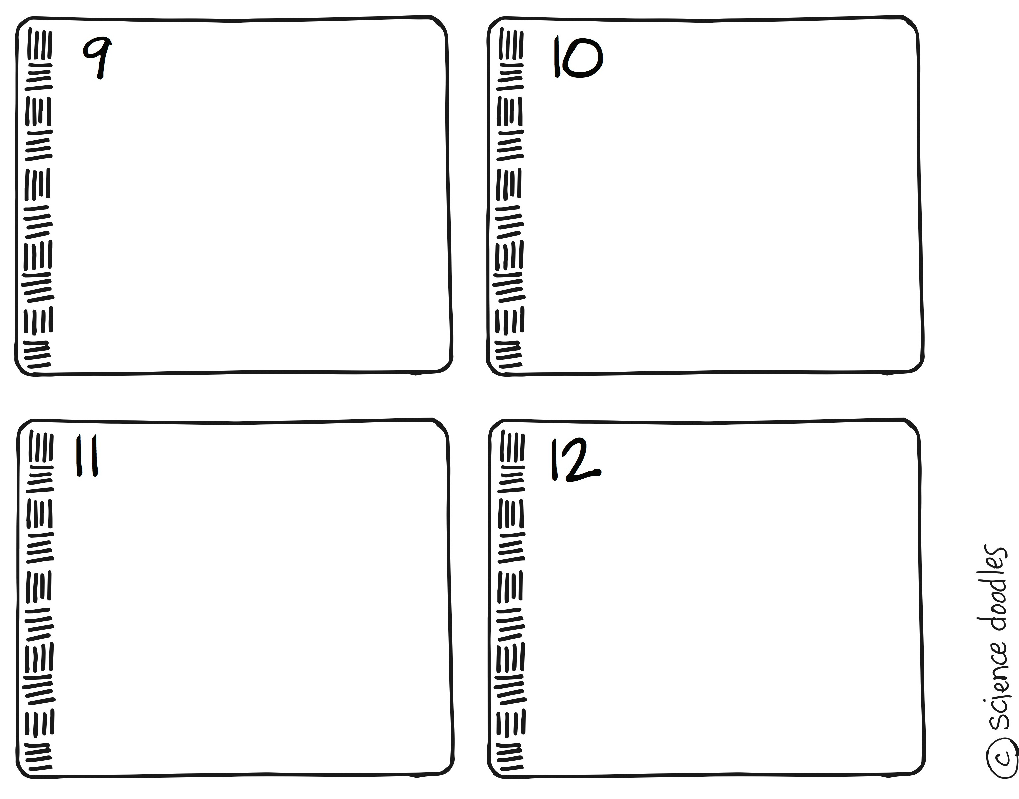

Inherited traits & learned behaviors Inherited traits & learned behaviors

Which one is an inherited trait?
- doing your homework
- a bear hibernating in the winter
- a parrot saying hello
Which one is a learned behavior?
- webbed feet
- types of earlobes
- how to use a calculator

Inherited traits & learned behaviors
Inherited traits & learned behaviors

Which one is an inherited trait?
- a dog catching a Frisbee
- setting up a tent
- a turtle laying eggs on a beach
Which one is a learned behavior?
- segmented body
- bears catching salmon
- number of eyes

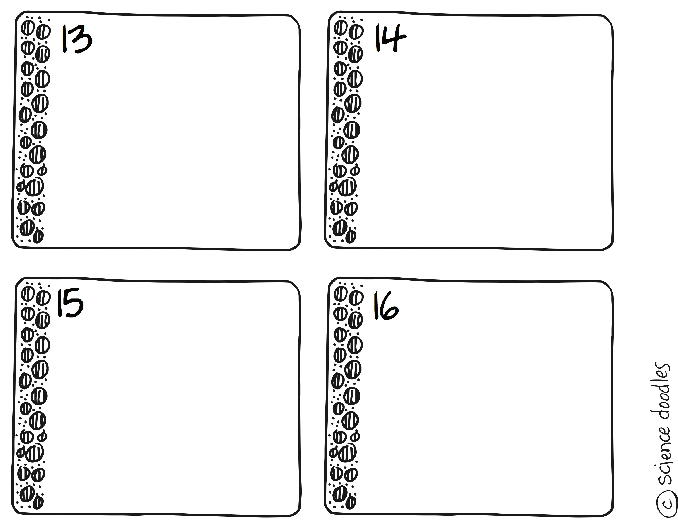

Inherited traits & learned behaviors Inherited traits & learned behaviors

Which one is an inherited trait?
- speaking Chinese
- cleaning the dishes
- curly hair
Which one is a learned behavior?
- how to make a sandwich
- dimples
- eye color

Inherited traits & learned behaviors
Inherited traits & learned behaviors

Which one is an inherited trait?
- swimming
- sharp teeth on a fox
- catching a fish
Which one is a learned behavior?
- playing the piano
- webbed feet
- bat wings

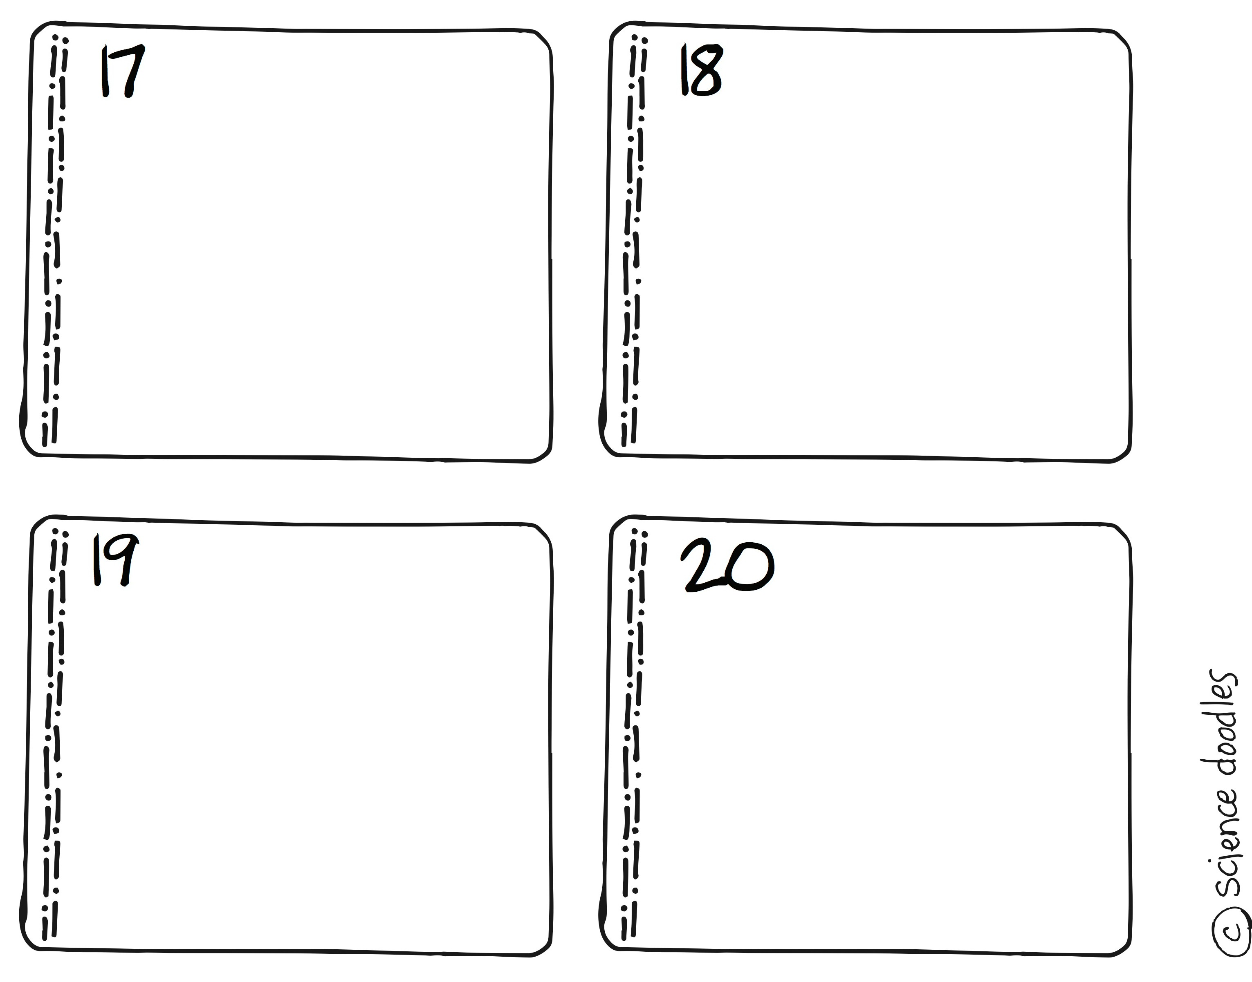

Inherited traits & learned behaviors Inherited traits & learned behaviors

A living thing?
- trait
- heredity
- organism
A characteristic of an organism?
- offspring
- learned behavior
- trait

Inherited traits & learned behaviors
Inherited traits & learned behaviors

A characteristic that is past from parents to offspring during reproduction?
- inherited trait
- learned behavior
- organism
A behavior that develops from observation or instruction rather than being passed down by heredity?
- Inherited trait
- learned behavior
- offspring

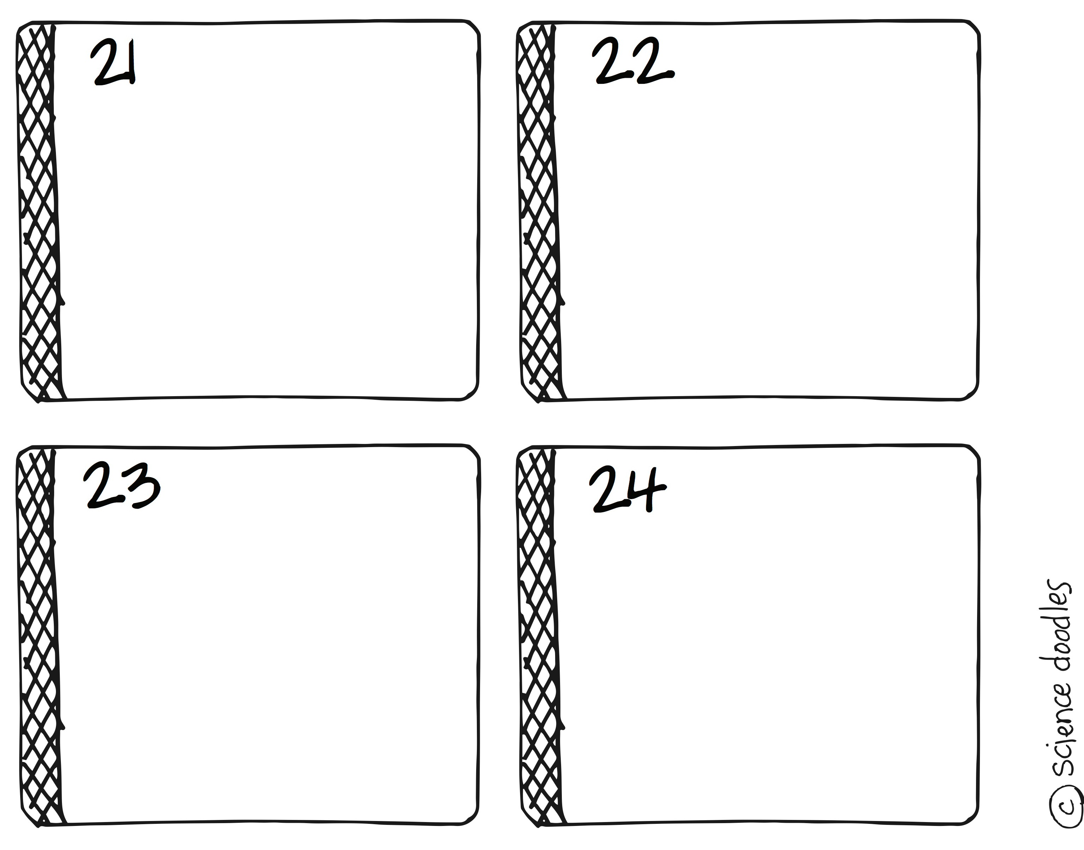
Inherited traits & learned behaviors Inherited traits & learned behaviors

New organism that come from parents that have reproduced?
- learned behavior
- offspring
- inherited trait
The passing of characteristics from one generation to another?
- heredity
- offspring
- organism

Inherited traits & learned behaviors
Inherited traits & learned behaviors

An instinct is the same as a learned behavior?
- true
- false
Some traits are inherited from parents to offspring?
- true
- false

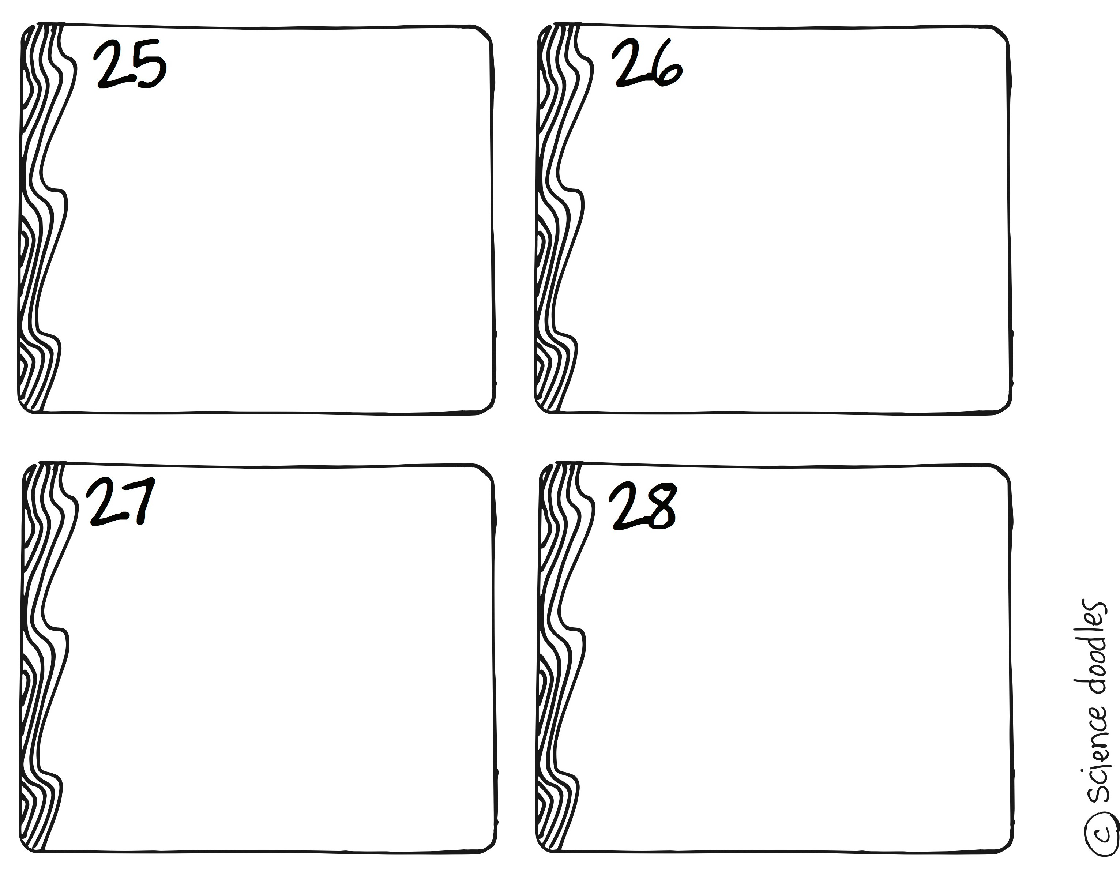

Inherited traits & learned behaviors Inherited traits & learned behaviors

Animals can learn how to hide or hunt?
- true
- false
Playing the guitar is an inherited trait?
- true
- false

Inherited traits & learned behaviors
Inherited traits & learned behaviors

Plants cannot have inherited traits?
- true
- false
Good manners are an inherited trait?
- true
- false

