Name: _ Date: Class:

Logic of Shapes
  - Label each shape in this diagram with the name that describes it most exactly. You can number the shapes and list the names on the back or write the names on the diagram.
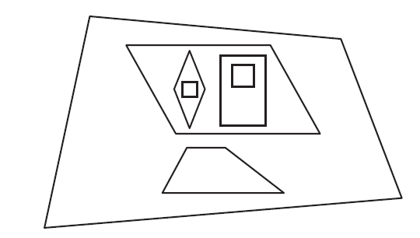
  - Why is the trapezoid inside the quadrilateral but outside the parallelogram?

  - Why are there a rhombus and a rectangle inside the parallelogram?

  - Why are there two squares, one inside the rhombus and one inside the rectangle?

  - Write at least 2 other observations to explain why the shapes in this diagram have been placed where they are in relation to each other.

  - Do you agree with the placement of the trapezoid? Redraw this diagram to show the actual relationship of the trapezoid to the parallelograms.

  - Which shape can be given the most names? Why?

  - What is the difference between a rhombus and a square?

