Due Date:

- You will be selecting an appetizer, main course, and dessert for this project from the recipes available in class. (If you wish to bring in your own recipe it must be checked by [Insert teacher name here]

- You must first see what the serving size of your recipe is.

- You may need to double, triple, or even quadruple your recipe to change the recipe so there would be enough for our class. Some items may not all be in fractions (Example: 1lb of chicken), but at least three items in each category must be a fraction. This project requires adding and multiplying of fractions.

- When finished the chart data must be written for display.

- All three recipes must be put on the poster board or made into a small recipe book.

- Visuals of the food must be included as well.
*You are not actually making these items. It is just a project *

Class time will be given to work on this project. Majority (if not all) of this project will be completed in class.
However, if you do not complete this project in the time given you will need to finish on your own time.
---------------------------------------------------------------------------------------------------------------------
HOMEWORK GRADE
Return this portion of the page signed by your parent/guardian
Please sign and detach this portion indicating that you have read the project guidelines and grading scale. *Projects count as a test grade
Student name:________________________________Student Signature:________________________
Parent/Guardian Signature:________________________________________________________
Class time will be given to work on this project. Majority (if not all) of this project will be completed in class. However, if you do not complete this project in the time given you will need to finish on your own time.

Grading Scale

Choosing 1 appetizer, 1 main course, and 1 dessert | _______/10
Correctly manipulating 3 fractions in appetizer recipe to serve 24 people | _______/15
Correctly manipulating 3 fractions in appetizer main course recipe to serve 24 people | _______/15
Correctly manipulating 3 fractions in appetizer the dessert recipe to serve 24 people | _______/15
All work shown | _______/10
Displaying the recipes with original fraction and new fractions (Recipe book or poster board) | _______/20
Neatness and Creativity | _______/10
Total | _______/100
Comments:

Appetizer Title :

Originally Serves:

Items | Original Amount | Work space to find out how much to make recipe for 24 or more servings | New amount to 24 servings

Main Dish Title :

Originally Serves:

Item | Amount | Work space to find out how much to make recipe for 24 or more servings | New amount to 24 servings

Dessert Title :

Originally Serves:

Item | Amount | Work space to find out how much to make recipe for 24 or more servings | New amount to 24 servings

Appetizer

Buffalo Chicken Dip
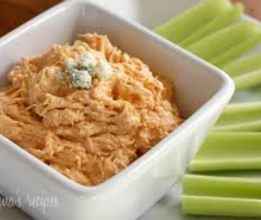

Makes 6 servings (Will need to times this recipe by 4)
Ingredients :
3 pounds chicken breast, boneless
½ cup bleu cheese
¼ cup Red hot sauce
1/3 Cucumber Ranch Dressing

Appetizer
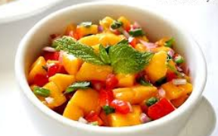
Mango Salsa and Chips
Makes 6 servings (Will need to times this recipe by 4)
Ingredients:
1 mango, peeled and diced
1/2 cup peeled, diced cucumber
1 tablespoon finely chopped jalapeno
1/3 cup diced red onion
1 ½ cup tomatoes

Appetizer
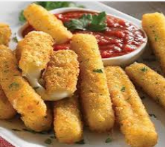
Mozzarella Sticks
Makes 12 servings (Will need to double this recipe)
Ingredients:
1 ½ cups of mozzarella cheese
¼ cup of milk
1/3 cup bread crumbs

Appetizer
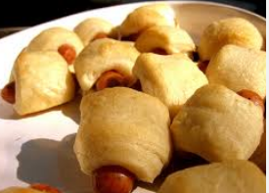
Pigs in a Blanket
Makes 15 servings (Will need to double this recipe)
Ingredients:
1 can refrigerated crescent rolls
2 ½ cups of chopped hot dogs
1/8 cup of ketchup
1/10 cup of mustard

Main Dish
Baked Ziti
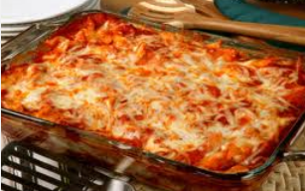
Makes 12 servings (Will need to double this recipe)
Ingredients:
1 3/4 cups of mozzarella cheese
2 1/3 cup of tomato sauce
1 ½ lbs of penne pasta

Main Dish
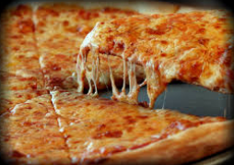
Pizza
Makes 8 servings (Will need to triple this recipe)
Ingredients:
1 ¼ cup of flour
2 eggs
1/8 teaspoon baking soda
1 cup of tomato sauce
2 ¼ cup of mozzarella cheese

Main Dish
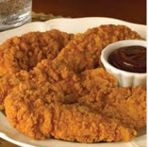
Chicken Tenders
Makes 12 servings (Will need to double this recipe)
1 1/3 cups oil, for frying
2 pounds boneless, skinless chicken breasts
3 eggs
2 ½ cups all-purpose flour
1/3 teaspoon salt and pepper

Main Dish
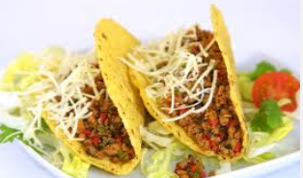
Tacos
Makes 8 servings (Will need to triple this recipe)
Ingredients:
8 taco shells
1lb beef or chicken
½ taco seasoning
2 1/8 cups of cheddar cheese
1/3 cup of shredded lettuce

Dessert
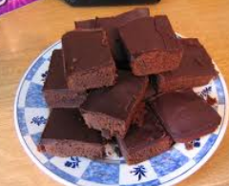
Brownies
Makes 20 servings (Will need to double this recipe)
1 1/4 pounds unsalted butter
2 1/2 pounds semisweet chocolate chips
6 extra-large eggs
2 2/4 cups sugar
1 cup all-purpose flour

Dessert
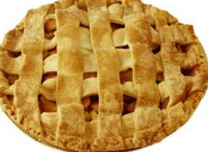
Apple Pie
Makes 8 servings (Will need to triple this recipe)
Ingredients:
4 pounds Granny Smith apples, peeled, quartered, and cored
2/3 cup sugar
1/4 cup all-purpose flour
1/8 teaspoon salt
1 egg

Dessert
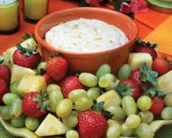
Fruit and dip
Makes 12 servings (Will need to double this recipe)
1 cup of cream cheese
1 1/3 cup marshmallow fluff
1/2 cup of green or purple grapes
¼ cup of strawberry
2 cups of pineapple chunks

Dessert
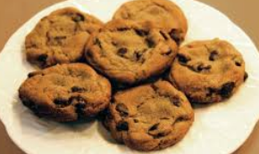
Chocolate Chip Cookies
Makes 12 servings (Will need to double this recipe)
Ingredients:
1/2 cup (1 stick) unsalted butter
1 1/3 cup sugar
2 large eggs
1 (12-ounce) bag semisweet chocolate chips, or chunks
2 1/4 cups all-purpose flour

