Act 2 Images
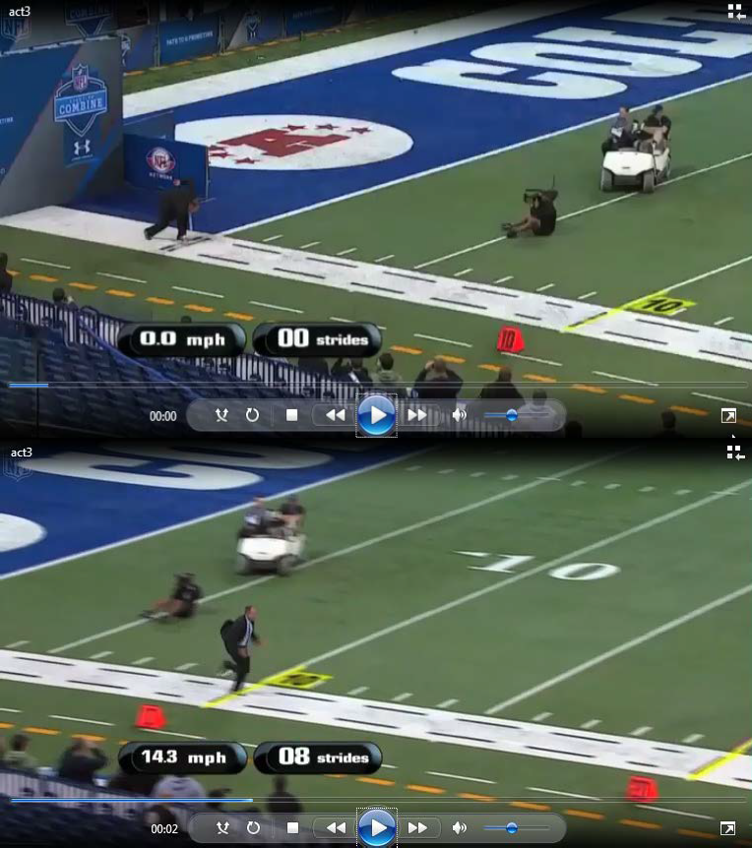

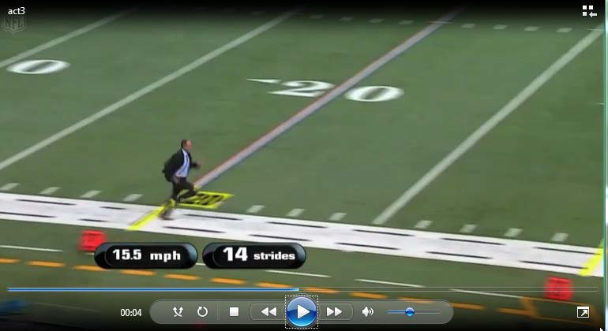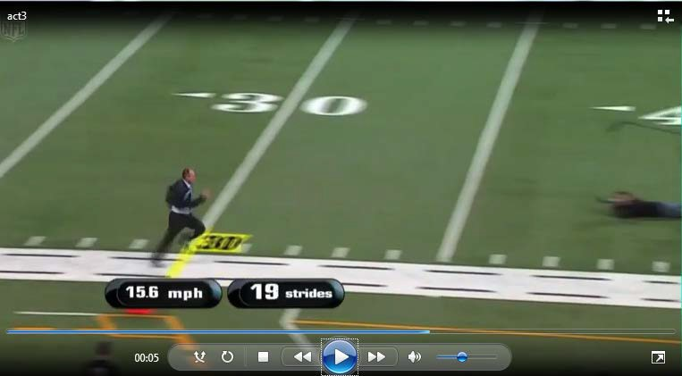

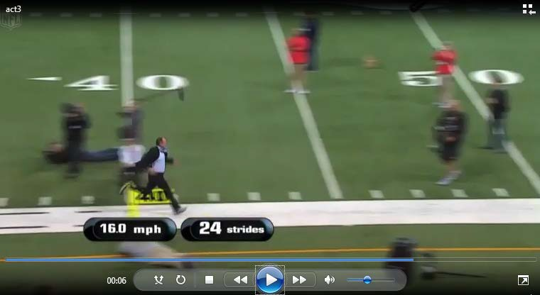

Three Act Student Recording Sheet Name

ACT 1
What questions come to your mind?

Main Question:

What is your first estimate and why?

Record an estimate that is too low and an estimate that is too high.

On an empty number line, record all three estimates made above.

ACT 2
What information would you like to know or need to solve the MAIN question?

Record the given information (measurements, materials, etc…)
If possible, give a better estimation with this information:

Act 2 (con’t)
Use this area for your work, tables, calculations, sketches, and final solution.

ACT 3
What was the result?

