A new amusement park has just opened in your town and you want to make sure you get as many rides as possible for your money. The park has two cost plans for visitors. Each plan includes a fee for admission and an additional charge for each ride. It’s up to you to decide which plan works best for you. Check out Plan A and Plan B in the boxes beside the graph.
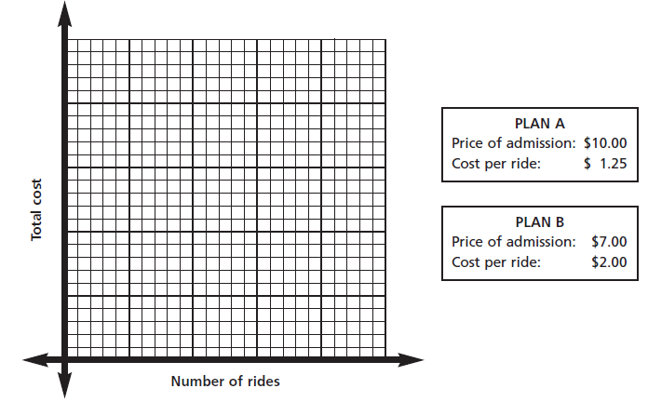
Complete the table for each plan to generate ordered pairs and create a graph to represent your results. Be sure to add numbers to the x and y axis before plotting your points. Highlight each plan with a different color. Review your results and create an argument for which plan you feel is the better buy.

Plan A-Rule
Number of Rides | Total Cost
0 | 10.00
1
2
3
4
5
6
7
8
9
10

Plan B-Rule
Number of Rides | Total Cost
0 | 7.00
1
2
3
4
5
6
7
8
9
10

Which plan is the better buy? Justify your reasoning.

